Project Initialization and Planning Phase

Date | 18 September 2026
Team ID | MCA
Project Name | Smartphone Usage, Digital Addiction & Well-Being Analytics
Maximum Marks | 3 Marks

Define Problem Statements:

The organization needs to understand why 5,308 of its 7,500 users (70.77%) are classified as
addicted to smartphone usage, and which factors — screen-time behavior, lifestyle habits, stress,
or demographic characteristics — most strongly correspond with that classification. Without
this understanding, product and research teams cannot prioritize well-being feature investment
or design targeted digital-health interventions.

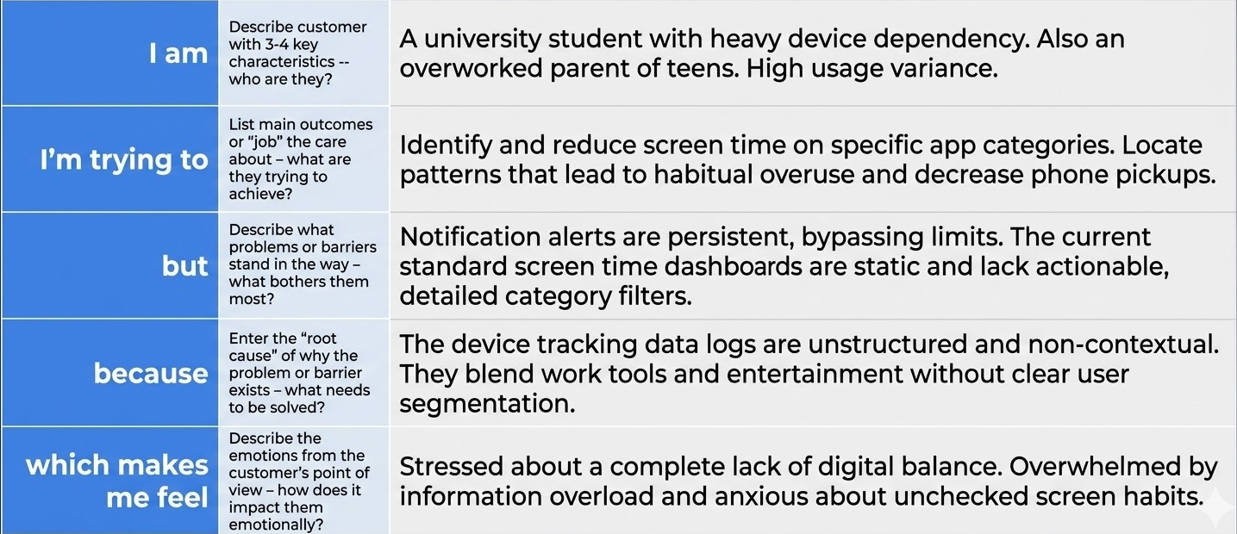

Example:

